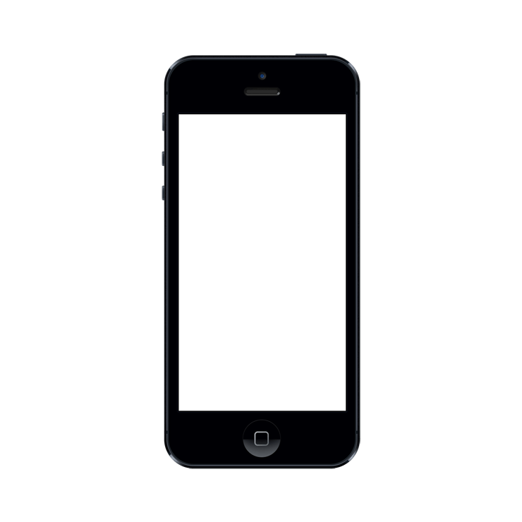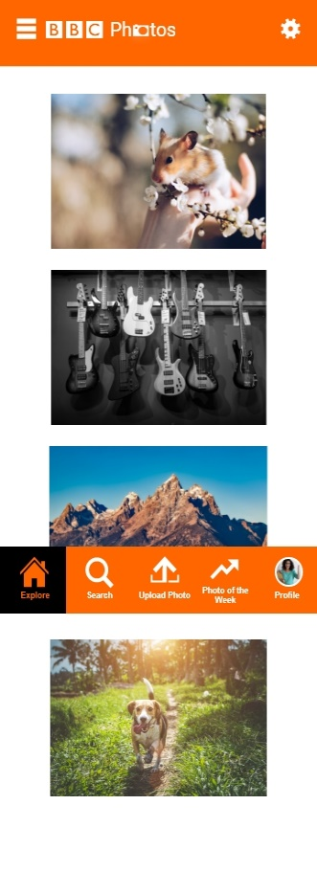

Andrew Gaw

S1626042

**BBC Ph tos**



Response to the Brief

When looking to engage with the 18-24 year-old demographic, it is important to first analyse exactly who people in this age range are and how they like to spend their time.

Research Survey

A survey was created to gain further insight into how 18-24 year old’s use social media, specifically with regards to sharing photos. A total of 20 respondent’s answers were recorded.

Online Interviews

Interview 1 – University Student

* Takes Photos Daily.
* Uploads Photos Daily.
* Sometimes Uploads multiple per day
* Uploads Photos to Instagram and Snapchat.
* Feels positive when she receives photo interactions.
* Says she likes posting photos to share experiences with friends and family.

Interview 3 – Unemployed Person

* Takes Photos Daily
* Uploads a few photos per week
* Uploads Photos to Instagram only.
* Feels positive when she receives photo interactions
* Says she likes the positive attention and being able to share memories with others

Interview 2 – Employed Worker

* Takes Photos a few times per week.
* Uploads Photos every so often.
* Posts photos on Facebook and Instagram.
* Feels very positive when he gets photo interactions.
* Says he likes posting photos as it allows others to see a glimpse of what he does.

The Opportunity

The research into the age demographic alongside the results of the Research Survey and interviews which shows a strong positive connection between the photos which respondents upload online and the responses they reactions they receive to create an application which allows users to create themed photo albums, share these albums with their friends and also get the opportunity to have their photos added to a photo of the week page via weekly competition entry, allowing the users photo’s to then be displayed to an even larger audience.

What types of apps they use?

* Social Media.
* Media Streaming.
* Online Shopping.
* Online Banking.
* Games.

What they do with their time?

* Sleep 5.96-7.1hrs per night.
* 35.5hrs per week spent online.
* 1 in 3 are in higher education.

What devices they have access to?

* Mobile Phones.
* Computers/ Laptops.
* Tablets.
* Games Consoles.
* Regular/Smart TVs.
* Smart Watches.

Who They Are?

* Students.
* Graduates.
* Employed.
* Unemployed.
* Self-Employed.
* Young Couples.
* Young Families.

Define

Why an Application?

Initial research found that while 99% of the target demographic had access to and made us of a mobile phone, only 75% had access to computers, laptops and tablets. Out of that 75%, 67% and 65% said they used their computer/laptop and tablet respectively. Creating a mobile-based application helps to extend the ability to draw the target audience by offering the service to their most used device.

Connor Forth |



Age: 20

Occupation: Student

Location: Glasgow

Residency: Student Flat

Relationship Status: Single

Employment: Part-Time

BIO

Connor is a First Year student studying psychology at Strathclyde University. He stays in the local university accommodation and spends most of his time socialising with his new friends. Since he no longer lives with his family, he phones them weekly and goes home whenever he gets the chance. He also frequently posts photos on social media as he feels it is a good way to show family and his friends at home what he gets up to in Glasgow.

Goals & Needs

* Wants more time to relax during university term-time.
* Wants to get good results in his course. However, often struggles for motivation.
* Needs Mobile and Social Media access to communicate and share experiences with his family.

Most Used Apps

Personality & Fears



* Sociable
* Friendly
* Active

Fears: Losing contact with his old friend group.

Define



Jessica McDermott |

Age: 23

Occupation: Accountant

Location: Aberdeen

Residency: Rented Flat

Relationship Status: Engaged

Employment: Full-Time

BIO

Jessica is an Accountant who works full time in an office in Aberdeen. She lives alone in a one bedroom flat however plans to move in with her fiancé soon. Outside of work, she struggles to find time to relax and unwind and spends most of her evenings watching her favourite shows on her laptop. Due to her busy days, she is often left dissatisfied with her routine and would love to take up a new hobby that she can focus on during weekends and holidays from work.

Goals & Needs

* Wants to move into accommodation with her fiancé soon and settle down.
* Wants to get a pet dog however is not allowed pets in her current residence.
* Needs a new hobby to change up her day to day routine and make her feel more satisfied outside of work.

Most Used Apps

Personality & Fears

* Organised
* Sociable
* Animal Lover

Fears: Becoming trapped in a dull routine.

Pinterest |

* Ability to select preferred topics to see on Main Page.
* Bottom Navigation similar to Instagram.
* More cluttered layout than Instagram, less appealing on the eye.
* Search function also provides popular searches
* Ability to alter between Boards and Pins on Profile.
* Very simple interface.
* Easy Bottom Navigation.
* Use of meaningful icons for easier navigation.
* Ability to search by username or hashtags.
* Clear icons for like, comment & send on photos.
* Ability to change layout of photos between single and grid view on profile.

Instagram |

Competitive Analysis

Connor is a young student currently studying at Strathclyde University. He has only recently moved to Glasgow and as such, is still trying to balance studies while keeping in contact with his family and friends. He has begun to make new friends on his university course however worries that he could lose contact with his friends from his hometown and doesn’t want to replace them. Connor tries his best to speak to both his old and new friends but worries he won’t be able to combine the two groups while also showing his family what he has been doing at university. As such, Connor wants to be able to create a collection of his photos from his first year of university which he can share with both his friends and family, allowing him to combine photos of his hometown friend group, university friend group and his family and share his experience of his first year with all three groups.

Jessica lives in Aberdeen and works as a Full-Time Accountant. She works long weekday hours and feels she has very little time to herself between getting home from work and going to bed. She feels dissatisfied with her regular day to day routine and as such decided to buy a regular DSLR Camera and would like to take up photography and start taking photographs during her free time. However, she worries her pictures aren’t as good as those taken by photographers with more experience and feels she won’t be able to get feedback on her photographs due to her lesser experience. She would like to be able to upload her photographs somewhere to receive constructive criticism on the pictures she takes and have the opportunity to share her good photographs with a wider audience.

Scenarios

Jessica McDermott | Scenario 2

Connor Forth | Scenario 1

Insight

Application Objectives

* Should be easily accessible for users of all technological ability.
* The application must provide personalisation of the type of photos the user would most like to see.
* The application should also give the user the ability to search for other album types.
* The app must be appealing for the 18-24 year old demographic.
* Users must be able to add photos to albums and be given the option to submit these photos to the weekly competition.

Features

Define

The Must Have features are:

* Sign up
* Photo upload
* Photo of the Week Competition
* Search Function
* Interested Album Selection
* Profile
* Remove an Album
* Upload Profile Photo

The higher satisfaction levels are found from most of the must have features.

The features identified as having lower satisfaction levels include Signing up, Settings and Profile deactivation, as signing up and changing settings are often thought of as boring interactions, while the deactivation of a profile indicates that the user is not satisfied with certain or all aspects of the application.

Must Have Features & Satisfaction Levels

Satisfaction levels are used to identify the importance of each feature.

Satisfaction Levels of Key Features

A breakdown of the main features and their importance based on the Needs & Goals.

* 18-24 Year olds with various lifestyles who enjoy taking and sharing photos.
* Photographers of any skill level looking for the ability to share their pictures to a wider audience.

Share or export Albums to other Services (Email, Social Media etc).

Search for Username, or Album Name Tag.

Opt in to submitting photos to the ‘Photos of the Week’ Competition.

Update or Remove Albums.

Add photos to new or existing Albums.

Select the main types of albums they would like to see.

User Needs & Goals

Stakeholders

Design Brief & Application Vision

Define

Colour Combination Ideas

Typography

BBC Reith Sans Light

BBC Reith Sans XBold

BBC Reith Sans Medium

Specific BBC resources will be used throughout the application such as icons and the BBC typography to ensure the application fits in with other services in the BBC family. Icons from other BBC services will also be used in the photos of the week section to help advertise some of the other services which the BBC provide.

BBC Branding

Personalisation will be used to allow users to specify the types of albums they would like to see appear on their home page. These preferred albums will be changeable at any time via the settings, allowing each user to customise the exact type of photos they will see in the application whenever they like.

A simplistic, bottom navigation bar will be utilised on each page to improve the ability of understanding through repetition. Each icon in the navigation bar will make use of meaningful text and relevant icons to ensure the user knows where each menu item will take them and what functionality each will provide.

User Personalisation

Neat Album Layout

The interface will make use of a layout which ensures there are never too many albums on screen at a time, and when opening an album, the photos inside are laid out in a manner which is appealing to the eye and not too overwhelming or busy on the screen.

Consistent Navigation

Add photos to new or existing Albums.

Submit Photos to Photo of the Week.

Search for Username, or Album Name Tag.

Edit or Remove Albums.

Explore page to show albums of interest.

Album type selection for Interest.

Key Features

The Main Goals from the brief are to:

* Engage with more users of the target demographic.
* Increase the usage of all BBC services by linking the application to other available services.

Specific Goals of the Application are to:

* Allow users to upload photos to tag-based albums.
* Provide users with the option to enter a photo into the Photo of the Week competition.
* Display albums to users based on the interests they set when creating their profile
* Allow users to update these interests at any time in the settings.
* Give users the ability to comment on other people’s albums.
* Provide the ability for users to search for other user’s profiles or types of albums.
* Let users delete albums on their profile.
* Adhere to BBC Design Guidelines throughout the design of the application.

The brief for this project is to create a new BBC Product which is different to the services currently offered by the company and is attractive to the 18-24 year old demographic. Initial Research found that social media services are widely utilised by the demographic and the survey found that all these users feel positive benefits when posting photos online and receiving interactions on those photos.

BBC Photos is an application which will allow users to create albums of photographs based on the type of photograph being uploaded. Users will also be able to search for specific types of albums based and be able to leave positive comments on other user’s albums. A Photos of the Week competition will also be available, allowing users to submit specific photos based on the topic area of the competition each week.

At the end of the week the BBC will select their top 10 photos submitted and display these photos on an individual competition page, allowing users to see the photos in the top 10 each week. The weekly competition will also allow for the incorporation of other BBC services such as sports themed weeks to promote BBC Sports, or themes based on BBC Television shows to help promote BBC television channels and iPlayer.

Design Principles

Business Goals



Ph tos

App Icon

User Journeys

User Journeys were created based on the personas and scenarios highlighted in the define section. The journeys grant insight into how each persona would utilise the application and how they would feel while trying to complete their desired aims on the app.

Develop

Connor’s Journeyey

Jessica’s Journey

Develop

Application Structure

Main Functionality Pages

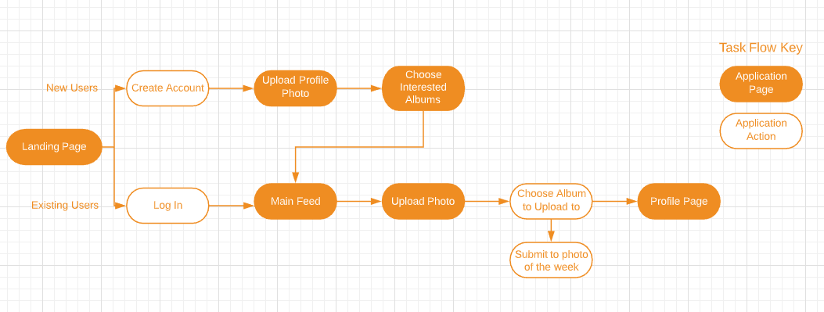

The application structure helps to give a more visual representation of how each of the pages will be connected and the functionality provided on the pages. The application structure represents all pages within the application and how the user can access each page.

The task flow helps to represent how a user could interact with the application to upload a photo to an album. It helps to visualise the journey the user would take through each relevant page when attempting to achieve their final goal.

Task Flow

User wanting to Upload Photos

The initial idea for the main pages required by the application are:

* Sign In/Register
* Main Feed (Explore)
* Search
* Upload Photo
* Photo of the Week
* Profile
* Album Page
* Photo Page
* Settings

Additional Pages which could be used in the application are:

* Landing Page
* Upload Profile Photo Page
* First Time Account Creation Welcome Page
* Optional Tutorial for new Users
* Edit/Delete Albums page
* Nonfictions/Comments

Additional Pages

Initial Sketches

Initial Sketches of the application were created based on the user journeys for Connor & Jessica. Basic functionality for viewing creating an account, selecting albums, viewing the main feed, and accessing the user profile were all created to highlight how the application would function.

Two landing pages were also designed, one which made use of a singular background image and the other which made use of an Image Carousel. If the carousel page were chosen, the carousel itself could be populated by some of the submissions from the photo of the week competition each week.

Develop

Initial Wireframes & Design

Initial Wireframes were produced to build upon the sketches created. A landing page was used to help separate the Sign up and Register options, after following the action to create an account or sign in, the user is then taken to an explore page which shows them albums of their interests.

A bottom navigation bar is used to help improve the overall flow of the application while also keep the interface neat and easy to understand. Basic functionality for each of the navigation page options has been portrayed including the edit album functionality and comments in the profile section.

Develop

Feedback from the Wireframes

10 People within the target age demographic were shown both the initial wireframes and the first iteration of the main application design. Gaining feedback is paramount in ensuring that the demographic targeted enjoy the design, layout and functionality of the application.

5 of the people were also asked to watch an initial prototype video which allowed them to see how the create account process works, how interests are selected, and finally the layout of the main explore feed page. This video allowed for the finding of any concerns or questions which the demographic may have with the application while also allowing for the evaluation of how each user felt when following the main flow of the profile customisation section

Develop

While the Feedback was mostly positive, a few changes were noted. The addition of an Icon below the image carousel to help indicate its presence on the landing page was deemed hugely beneficial. Along with this the wording of the interested albums page and the album icon was changed to help visualise the user selecting albums rather than creating them. From here the application was further developed ensuring consistency between pages and the overall task flow. The second prototype created was shown to the same 10 users and the response was very positive.

Reaction to the Feedback

Carousel not obvious

Wording and Icon choice gives the impression that the User is adding album types to their profile rather than selecting albums they would be interested in seeing

* When asked about the difference in colour between the wireframes and the initial design prototype. All users said they preferred the brighter orange colour used for the main prototype. One user said the colour of the original wireframes reminded them of the BBC Sport App.

Key Points Found

* Users were positive about the feature of the weekly photo competition and most said they would enter the competition.
* Users felt they understood what each icon and button in the bottom navigation bar was for and felt the bar helped to organise the features of the application
* When viewing the Homepage, users were happy with the page only displaying albums which they previously selected an interest in.
* More than half of the users found that the wording of the interested album selection page, along with the icons used when an album is selected was quite confusing. They suggested that using the word “Select” rather than “Add”, along with using a Tick Icon rather than an Add Icon could remove this confusion, as at this stage the user is only “selecting” types of albums they would like to see and are not “adding” albums to their own Profile.
* When looking at the account creation process, users felt that the main action buttons being placed in the centre of each page helped to improve the understandability of each action.
* Users enjoyed the ability to personalise what types of albums they would see on their main feed.
* Users reacted very positively when being initially told what the application was and what features it would provide.
* It was noted on the landing page that most users did not realise the swipe Image carousel was present on the page. Adding an icon below the image could draw attention to it more.

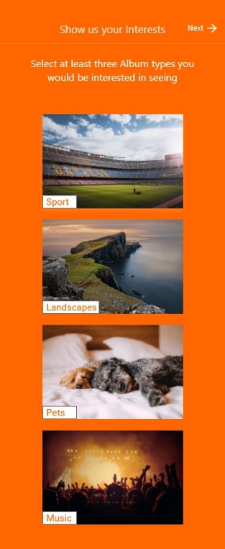

Prototype: https://xd.adobe.com/view/1f169280-01fe-4ea6-6c45-39bdd24833cd-6927/?fullscreen

Prototype Video: https://drive.google.com/open?id=1fu18JdjBaszq7WhgoNLZJ_S2WYMf1E75

Deliver | Final Solution

